|  |  |
| --- | --- |
|  |  |
|  | v6.3 Release |

24/09/2009

**High Level Design**

**Mark Higginson**

**HLD Version 0.0a**

# Revision and Signoff Sheet

## Revision

|  |  |  |  |
| --- | --- | --- | --- |
| Date | Author | Version | Change Reference |
| 24th Sept 09 | M Higginson | 0.1 |  |
|  |  |  |  |

## Reviewers

|  |  |  |  |
| --- | --- | --- | --- |
| Name | Position | Version Approved | Date |
| M Higginson | Software Technology Manager |  |  |
| P Rutherford | Analyst Programmer |  |  |
| J Waygood | QA Executive |  |  |
| M Roke | Release Product Manager |  |  |
| D Rustell | QA Manager |  |  |

Contents

Revision and Signoff Sheet 2

Revision 2

Reviewers 2

Purpose of Document 4

SDLC Checkpoints That Must Be Covered 4

Architecture 4

Deployment Analysis 4

Coding Standards 4

System / Platform Analysis 4

Source Control 4

Risks 4

Iterations 4

Requirements 5

Requirement Name and Number : 6.3.REA.36 – Exchequer Read-Only Mode 5

CD Licence Generator 5

Setup 5

# Purpose of Document

The purpose of the HLD (HLD) is to define the changes to be made to the program from a technical perspective.

# SDLC Checkpoints That Must Be Covered

## Architecture

No changes in architecture will be made in this release.

## Deployment Analysis

The upgrade process from v6.00/v6.01/v6.2 will require **???**, routines to automatically apply the changes will be developed and integrated into the Upgrade program so no additional steps will be required by the user.

**TBD**

## Coding Standards

The standard Exchequer Coding Standards will be applied.

## System / Platform Analysis

This release will continue to support the existing Systems and Platforms supported by Exchequer v6.2.

## Source Control

This release will be stored in the standard Exchequer repository using SubVersion (svn://bmtdev1/exchequer/trunk). It is expected that shortly before Code Freeze the source code and any related items will be moved to a new branch (svn://bmtdev1/exchequer/branches/v63) for release and long term maintenance.

## Risks

**TBD**

## Iterations

It is expected that builds will be made available to QA after completion of all significant tasks to allow for the earliest possible detection of faults.

The first significant milestone ?

**TBD**

# Requirements

## Requirement Name and Number : 6.3.REA.36 – Exchequer Read-Only Mode

**Requirement Type** : Functional

***Overview***

Modify Exchequer to handle Annual based licensing in addition to the Perpetual model currently used. On expiry of the Annual licence a 30-Day Grace Period will be given, if the licence isn’t renewed during that period the system will go into Read-Only Mode.

#### Detail Design

### SecRel

* Develop and Implement a new Exchequer System Release Code with embedded Expiry Date using a format like this:-

XXXXXXXXXX-YYYYYY-ZZZZ

Where XXXXXXXXXX is a standard system release code (30-Day / 1-Year), YYYYYY is an encoded Expiry Date to be applied to the system being released and ZZZZ is a checksum to ensure the details have been entered correctly (and prevent people trying to hack it).

* Develop and Implement a new security password to control access to the function in the MCM which switches the system between Annual and Perpetual

### CD Licence Generator

* Extend CD and Exchequer Licence structures to include the new Licence Type – Annual/Perpetual and Licence Expiry Dates:-

// MH 24/09/2009 v6.3 – Added new System Licence Type

licSystemType : Byte; // 0-Perpetual Licence, 1=Annual Licence

// MH 24/09/2009 v6.3 – Added new System Licence Type

licSystemExpiry : TDateTime; // Expiry Date for Annual Type Licence

### Setup

* Copy new licence fields from CD Licence to Exchequer Licence (Entrprse.Dat)

### Exchequer

#### MCM

* Modify System Release Code dialog
* Add password protected function to allow licence to be switched between annual and perpetual without requiring an upgrade – reset system release codes to 7 days on change.

Enter1

Toolkit DLL & COM Toolkit

OLE Server

eBusiness

Outlook Dynamic Dashboard

### WebRel

* Extend version for v6.3
* Add Licence Type (Annual/Perpetual) to Customer’s ESN Table
* Add Licence Expiry Date to Customers (For Annual Licence Type Only)

Add Licence Type and Expiry Date to Customer Information section:-

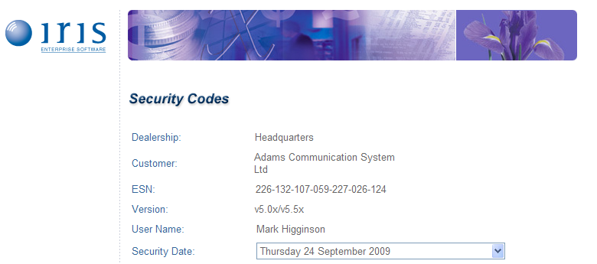

* Modify
* WR Listener – Extend for Licence Type and Licence Expiry Date